DevelopersHub Corporation

Software Quality Assurance (SQA) – 3 Week Project Week 2 – Test Planning and Advanced Testing
Project Title: Bug Tracking and Test Automation for a Web Application
System Under Test: SweetNSwirls – Android Ice-Cream Ordering Application
GitHub Repo Link Of Project: https://github.com/anam125/sweetnswirls Student: Anam Saghir
Submission Date: 23 March 2026

Introduction
In Week-1 of this project, manual testing was performed on the SweetNSwirls Android application, and several potential issues were identified and reported using the issue-tracking tool Jira.
Week-2 focuses on structured test planning and advanced testing techniques. These techniques help QA engineers design effective tests and ensure that the software works correctly under different conditions.
The main activities performed during Week-2 include:
- Creating a Test Plan Document
- Performing Black-Box Testing techniques
- Conducting Compatibility Testing
- Performing Bug Retesting and Verification
The application selected for testing in this project is Sweet n Swirl, which is a native Android ice cream ordering application.
Sweet n Swirl is developed using:

- Java
- XML
- SQLite Database
The application was developed in Android Studio as part of a Mobile Application Development course project.
The main purpose of this application is to allow users to browse dessert items, add them to a cart, and place an order easily through a mobile interface.

Features of the Application
The main features of the Sweet n Swirl application include:
- User Signup using SQLite Database
- User Login Authentication
- Persistent User Session
- Dessert Menu Display using RecyclerView
- Item Detail Screen
- Add to Cart Functionality
- Update or Remove Cart Items
- Checkout and Order Placement
- Order Confirmation and Order Summary
These features were selected for testing in order to ensure that the application works correctly and provides a smooth user experience.

Navigation Flow of the Application
The navigation flow of the application is as follows:
- Welcome Screen

- Login Screen
- Signup Screen
- Dessert Menu Screen
- Item Detail Screen
- Cart Screen
- Checkout Screen
- Order Confirmation Screen
- Order Summary Screen
Each of these screens was tested to verify functionality and usability.

Test Plan Document
  - Objective of Testing
The objective of this testing process is to verify that all major functionalities of the Sweet n Swirl application are working correctly and that users are able to navigate through the application without any errors.
The testing also aims to identify any functional or user interface issues that may affect the user experience.

Scope of Testing
The scope of testing includes testing the following modules:
    - User Registration
    - User Login
    - Dessert Menu Display
    - Item Detail Screen
    - Add to Cart

    - Cart Management
    - Checkout Process
    - Order Confirmation
The testing focuses mainly on functional testing and compatibility testing.

Testing Approach
The testing approach used for this project includes the following methods:
- Manual Testing
- Black Box Testing
- Compatibility Testing
- Retesting and Verification
Manual testing is performed by interacting with the application and observing the results.
Black box testing techniques such as:
  - Boundary Value Analysis (BVA)
  - Equivalence Partitioning (EP)
are used to validate user input fields such as login and signup forms.

Resources Required
The following resources are required for performing testing:

Resource | Purpose
Android Studio | Running emulator and testing the application
Physical Android | Testing real device compatibility

Device
Google Sheets | Writing and managing test cases
Jira | Bug tracking and reporting

Testing was performed using Android Studio emulator and physical Android devices.

Test Environment
The test environment used for this project includes:

Component | Description
Development Tool | Android Studio
Programming Language | Java
UI Language | XML
Database | SQLite
Device | Android Emulator
Device | Physical Android Phone

The emulator and devices were used to ensure that the application works correctly in different environments.

Entry Criteria
The testing process begins when the following conditions are met:
    - Application build is successfully generated.
    - Application is installed on the testing device.

    - All main application modules are implemented.

Exit Criteria
Testing will be considered complete when:
    - All test cases have been executed.
    - Identified bugs are reported.
    - Retesting has been completed.
    - The application performs its core functionality without errors.

  - Testing Schedule

Task | Duration
Test Planning | 1 Day
Writing Test Cases | 1 Day
Performing Testing | 2 Days
Bug Reporting | 1 Day
Retesting | 1 Day

- Black Box Testing
Black box testing is a testing technique where the internal code of the application is not examined. Instead, the tester focuses on the input and output behavior of the system.
Two important black box techniques used in this project are:
- Boundary Value Analysis (BVA)
- Equivalence Partitioning (EP)

- Boundary Value Analysis (BVA)
Boundary Value Analysis tests values at the edges of input ranges. Errors often occur at boundary values.

Example in SweetNSwirls:
Password field requirement:
Minimum length = 6 characters Maximum length = 12 characters
Test cases:

Test Case | Input | Expected Result
Below Minimum | 5 characters | System should reject input
Minimum Boundary | 6 characters | System should accept
Normal Value | 8 characters | System should accept
Maximum Boundary | 12 characters | System should accept
Above Maximum | 13 characters | System should reject

- Equivalence Partitioning (EP)
Equivalence Partitioning divides input values into valid and invalid groups.
Instead of testing every value, one value from each group is tested.

Example for email input:

Test Case | Input | Category | Expected Result
TC_EP_01 | user@gmail.com | Valid Input | Accepted
TC_EP_02 | usergmail.com | Invalid Input | Error Message

TC_EP_03 | user@ | Invalid Input | Error Message

This technique reduces the number of test cases while still covering possible input scenarios.

Compatibility Testing
Compatibility testing ensures that the application works properly across different environments.
Since Sweet n Swirl is a native Android application, cross-browser testing is not applicable. Instead, device compatibility testing was performed.
Testing was done on:

Device | Android Version | Result
Android Emulator | Android 11 | Working
Android Phone | Android 12 | Working
Android Phone | Android 13 | Working
All core functionalities such as login, menu browsing, and order placement worked correctly.

- Screenshot Placeholder for Compatibility Testing

Application running successfully on Android Emulator:
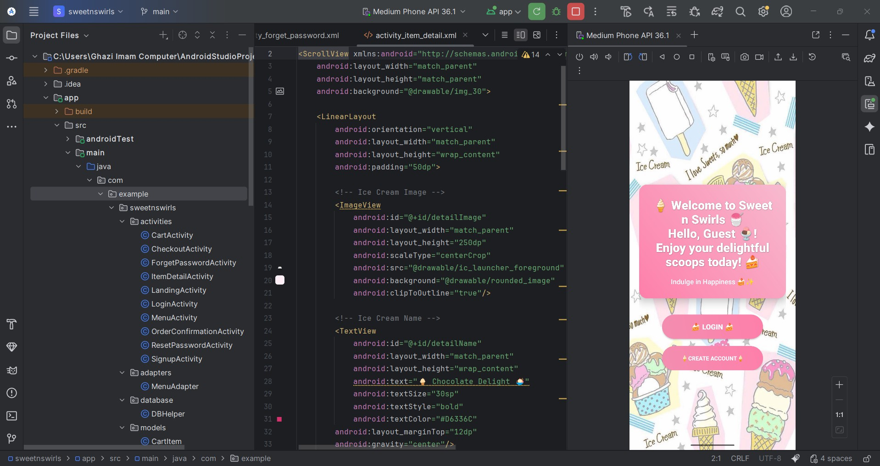


Application running successfully on Android Phone:

Retesting and Verification
Retesting is performed after bugs are fixed to ensure that the issues no longer exist.
During Week 1 testing, some minor UI and validation issues were identified and reported using Jira.
After corrections, the affected functionalities were tested again.

Retesting Results:

Bug ID | Original Issue | Status After Retesting
BUG-01 | Signup validation issue | Fixed
BUG-02 | Login error message missing | Fixed
BUG-03 | Cart icon not updating | Fixed
BUG-04 | Checkout button alignment | Fixed
BUG-05 | Menu image loading delay | Fixed

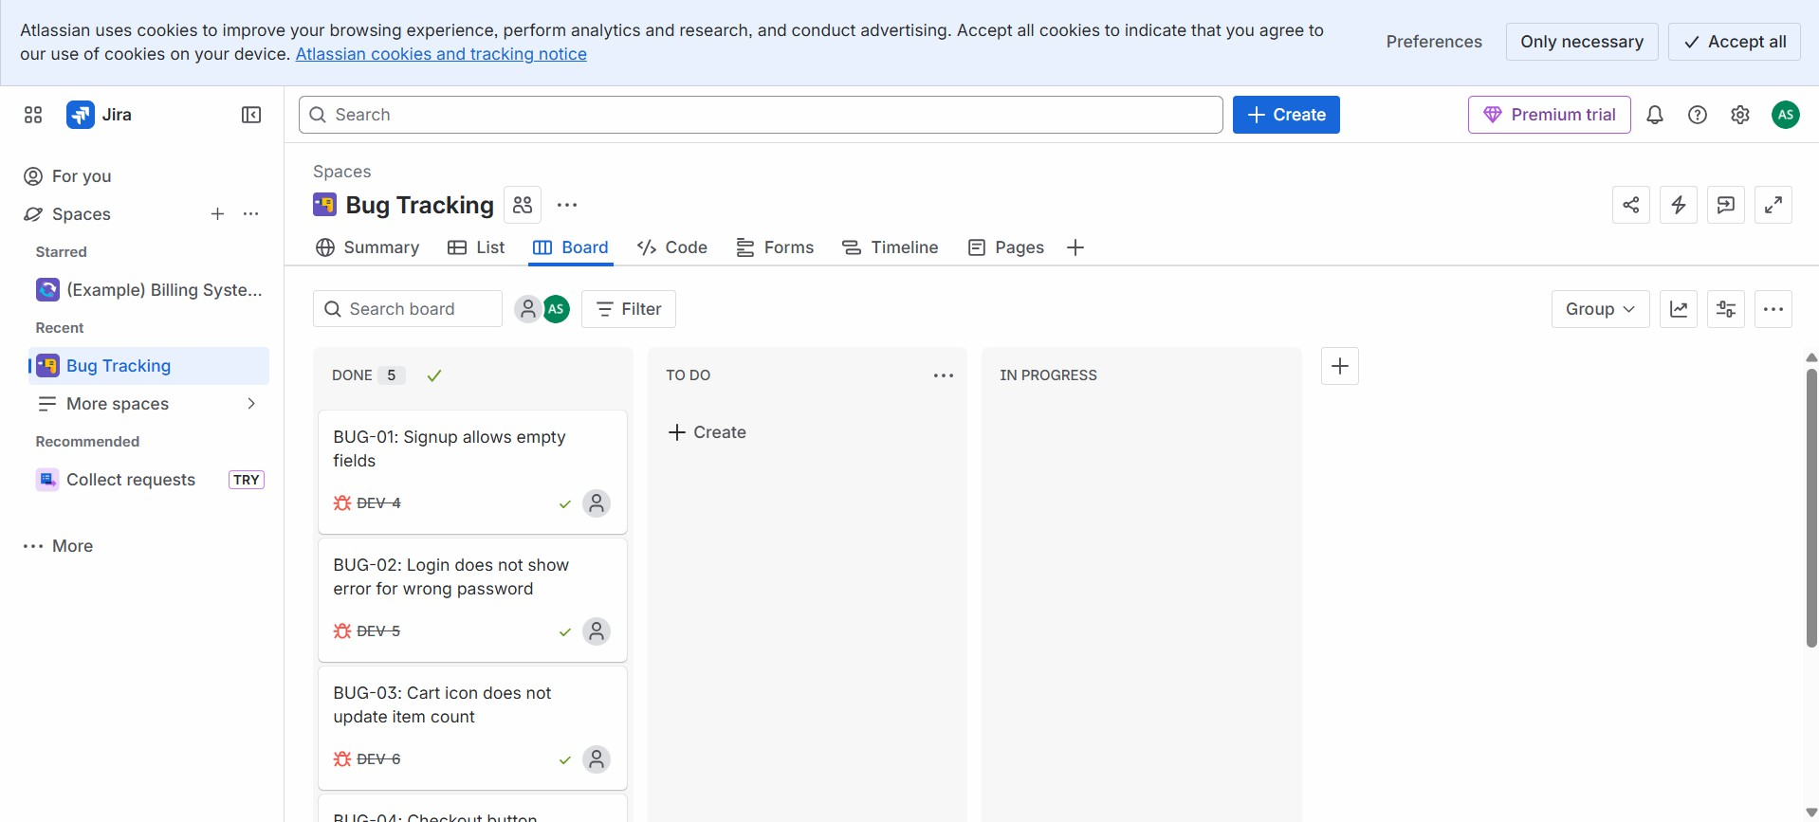

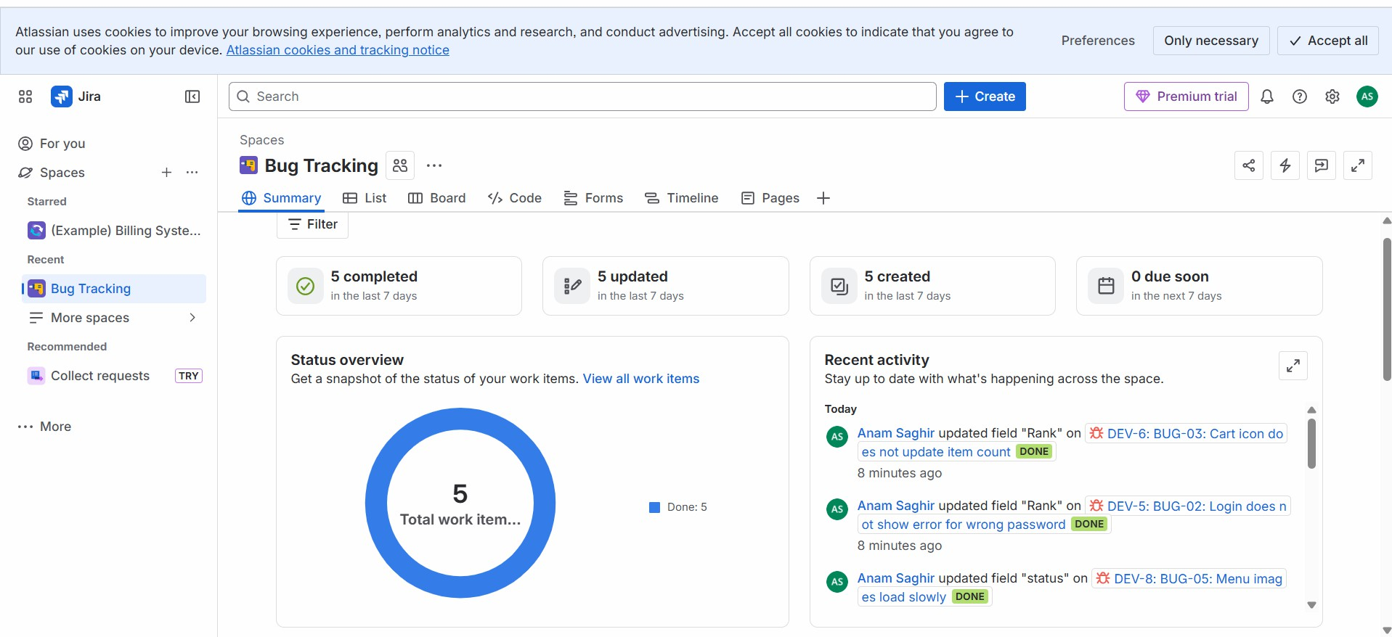

- Compatibility and Retesting Report
The application was tested on different Android devices to verify compatibility and stability.
The following observations were made:
- Application launched successfully on all devices.
- User login and signup functionality worked correctly.
- Dessert menu displayed properly without layout issues.
- Cart functionality worked smoothly.
- Order placement process completed successfully. No major compatibility issues were found during testing.

Conclusion
In this week, structured test planning and advanced manual testing techniques were implemented for the Sweet n Swirl application.

A detailed test plan was created to define the scope, testing approach, resources, and schedule. Black box testing techniques such as Boundary Value Analysis and Equivalence Partitioning were applied to validate user inputs.
Compatibility testing was also performed to ensure the application works properly across different Android devices.
The results showed that the application performs its core functionalities correctly and provides a stable user experience.

